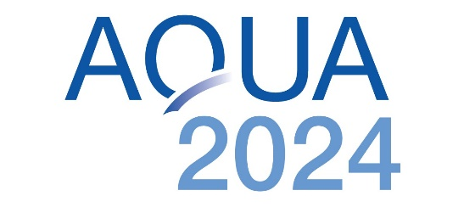

AQUA 2024 will be held in Copenhagen !
The Boards of Directors of the European Aquaculture Society and the World Aquaculture Society have just approved a change of location and date for the AQUA 2024 event, previously scheduled in Stavanger, Norway for June.
We are happy to announce that AQUA 2024 will take place from August 25-29 in Copenhagen. It will comprise a scientific conference, trade exhibition, industry forums, workshops, student events and receptions. The event will highlight the latest aquaculture research and innovation to underpin continued growth of this exciting food production sector. It will be a showcase for Denmark, and its innovation leadership in several key technologies crucial for future aquaculture, but also a meeting and exchange platform for experts from around the world.
The theme of AQUA 2024 is BLUE FOOD, GREEN SOLUTIONS.
Aquatic food is a major component of our food future, and Blue Food from all species in marine and freshwater production, is rightly in the spotlight for its potential to provide healthy, tasty and highly nutritious food for the planet.
Food systems transformation is a crucial requirement to mitigate climate impacts and offer enhanced food safety and security to billions. Aquaculture has demonstrated its resilience to change and is increasingly recognised for its environmental responsibility, reduced footprint and high efficiency in protein transformation and provision.
As our knowledge increases, so does our potential ability to offer Green Solutions throughout the aquaculture (and seafood) value chain. These solutions need not only to be financially feasible, they must also be based on the intelligent and sustainable utilisation of resources to maintain a measurable and limited footprint.
Blue Food production must grow. Green Solutions will help it to do so.
The AQUA events are co-organised by the European Aquaculture Society (EAS) and the World Aquaculture Society (WAS) and are held every six years. Past events were held in Nice (2000), Florence (2006), Prague (2012) and Montpellier (2018).
We look forward to welcoming you to AQUA 2024 Copenhagen ! August 25-29, 2024
Co-organised by EAS and WAS.
https://aquaeas.eu/ https://www.was.org/

